Name Period

Minerals & Rocks –Mini Lessons

Standard 4 Key Idea 3

Performance Indicator 3.1

Explain the properties of materials in terms of the arrangement and properties of the atoms that compose them.

Major Understanding:

3.1a Minerals have physical properties determined by their chemical composition and crystal structure.
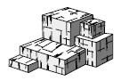

- Minerals can be identified by well-defined physical
and chemical properties, such as cleavage, fracture, color, density, hardness, streak, luster, crystal shape, and reaction with acid.

- Chemical composition and physical properties determine how minerals are used by humans.
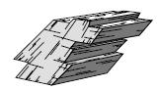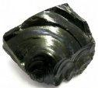

3.1b Minerals are formed inorganically by the process of crystallization as a result of specific environmental conditions. These include:

- cooling and solidification of magma

- precipitation from water caused by such processes as evaporation, chemical reactions, and temperature changes

- rearrangement of atoms in existing minerals subjected to conditions of high temperature and pressure.
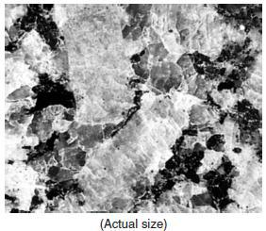

3.1c Rocks are usually composed of one or more minerals.

- Rocks are classified by their origin, mineral content, and texture.

- Conditions that existed when a rock formed can be inferred from the rock’s mineral content and texture.

- The properties of rocks determine how they are used and also influence land usage by humans.
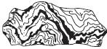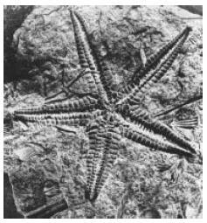

2.1w Sediments of inorganic and organic origin often accumulate in depositional environments. Sedimentary rocks form when sediments are compacted and/or cemented after burial or as the result of chemical precipitation from seawater.

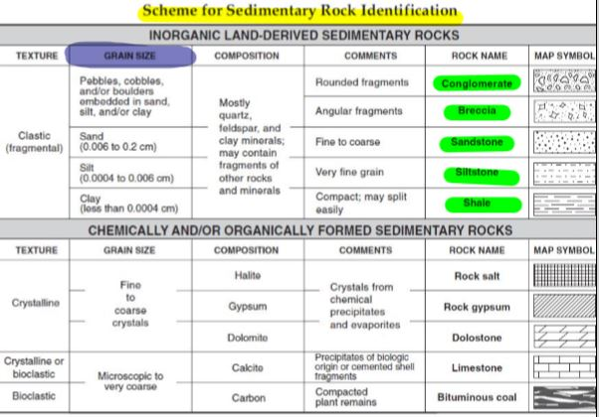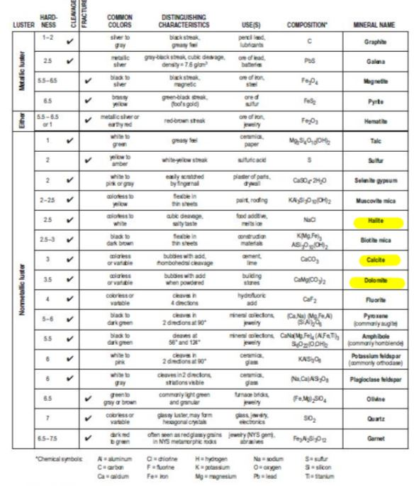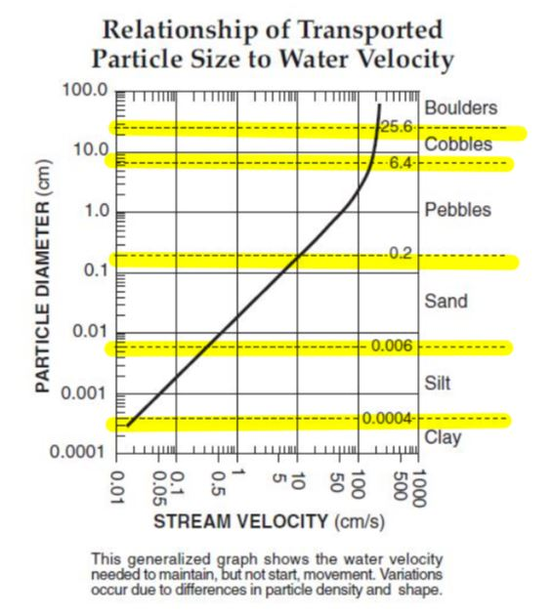
Mini Lesson 4: Sedimentary Rocks

Sedimentary rocks form from the deposition, burial, compaction and cementation of sediments. Clastic sedimentary rocks form from pieces and fragments of other rocks. Crystalline sedimentary rocks form from chemical precipitates and evaporites. Bioclastic sedimentary rocks form from something that was once living.

Sedimentary rocks are formed at or near Earth’s surface because that is where all of the weathering and erosion (breakdown and movement) of rocks occur. They are usually deposited in horizontal layers by water. Fossils provide evidence of past environments and are almost exclusively found in sedimentary rocks because the magma that forms igneous rock would melt the fossils, and the heat and pressure that forms metamorphic rocks would deform them.

Need to know:

- How do sedimentary rocks form? Sedimentary rocks form from the burial, deposition and compaction of sediments.
- What page of the Earth Science Reference Tables describe how Sedimentary rocks form? 7

- What do clastic rocks form from? Clastic rocks form from other rock fragments

- What do crystalline rocks form from? Crystalline rocks form from chemical precipitates and evaporates.
- What do bioclastic rocks form from? Bioclastic rocks are formed from parts of something that was once living.
- Where do sedimentary rocks form? Sedimentary rock form near the Earth’s surface, usually under water.
- Why do sedimentary rocks form where they do? They are formed at or near Erth’s surface under water because that is where the major of weathering and erosion take place.
- What do fossils provide evidence of? Fossils found in sedimentary rocks give clue about the past environment.
- Why are fossils found almost exclusively found in sedimentary rocks? Fossils are found in sedimentary rocks because magma (igneous rocks) would melt them and metamorphic rocks (cause by heat and/or pressure) would distort the fossils.
- The formation of which rock type would melt the fossils? Igneous rocks (molten magma) would melt the fossils.
- The formation of which rock type would alter or deform fossils? Metamorphic rocks (heat and/or pressure) would distort the fossils.

“Sedimentary Rock Chart” Earth Science Reference Tables Page 7

1. | Open your Earth Science Reference to page 7.
 |  |  | Materials
2. | Highlight the title “Scheme for Sedimentary Rock
 |  | ✓ | ESRT’s
 | Identification”. | ✓ | Highlighter
 |  | ✓ | Color pencils

- This table is divided into two basic sections (they are shaded gray). Name the two main categories for sedimentary rocks.

- Inorganic land derived

- Chemically and/or organically formed

- Looking at the top section, what is the texture listed? clastic

- These sedimentary rocks are formed primarily from pieces and parts (fragments) of other rocks. Find and highlight the rock names.

- Very carefully study this section of the table by looking at each column and the information beneath. What is the one major difference between each of these rocks? In other words, what makes shale different from siltstone and sandstone? Grain size

- Using a purple colored pencil, color in the column for “grain size” on the top section ONLY.

- The way in which clastic sedimentary rocks are classified is by grain size

- What is the name of the smallest fragment listed on this chart? clay

  - What is the size of the fragment? Less than 0.0004 cm

  - What is the name of the rock that forms from this size fragment? shale

10. Fill in the chart below. |  |  | Clastic Sedimentary Rocks:
 | Rock name | Grain size (name) |  | Grain size (cm) | Comments
 | Conglomerate |  | Mixed | Variable | Rounded fragments
 | Breccia |  | mixed | varies | angular fragments
 | Sandstone |  | sand | 0.006 to 0.2 cm | fine to coarse
 | Siltstone |  | silt | 0.0004 to 0.006 cm | very fine grain
 | Shale |  | clay | less than 0.0004 cm | compact, may easily split

- Turn to page 6 of the Earth Science Reference Tables. Refer to the graph labeled
“Relationship of Transported Particle Size to Water Velocity “.

- Using a highlighter trace over each of the dotted lines that run across the graph that have numbers listed on them to the right. These lines separate the different particle sizes.

- List the names and sizes of the particles in the table below from the largest to the smallest. Boulders is already done.

Particle Name | Particle size
Boulders | Greater than 25.6 cm
cobbles | 6.4 to 25.6 cm
pebbles | 0.2 to6.4 cm
sand | 0.006 to 0.2cm
silt | .0004 to 0.006 cm
clay | Less than 0.0004 cm

- Fill in the following chart using the Earth Science Reference Tables page 6: Relationship of
Transported Particle Size to Water Velocity” and the “Scheme for Sedimentary Rock Identification” table on page 7.

Grain size (cm) | Name of the Grain | Rock name
0.00001 | Clay | Shale
0.1 | sand | sandstone
0.002 | sand | sandstone
0.007 | silt | siltstone
0. 9 (round) | pebble | conglomerate
0.5 (angular) | pebble | breccia
0.00004 | clay | shale
0.005 | silt | siltstone

- The bottom section of the “Scheme for Sedimentary Rock Identification” table on page 7 has three different textures listed. What are they?
Crystalline, crystalline or bioclastic, bioclastic

- Very carefully study this section of the table by looking at each column and the information beneath. What is the one major difference between each of these rocks? In other words, what makes halite different from gypsum and dolomite?
The mineral composition for each rock is different and each mineral is constructed of different elements.
- Color in the column for “composition” purple on the bottom section ONLY.

- Clastic rocks are formed from other rocks, what do crystalline sediment rocks form from?
Look under “comments” The crystals form from chemical precipitates and evaporates

- Name the three crystalline sedimentary rocks.
Rock salt, rock gypsum, dolostone

20. What does limestone usually form from? Calcite that has been precipitated of biologic origin or cemented shell fragments

- What bioclastic material forms Bituminous Coal? Compacted plant remains

- Crystalline & Bioclastic Sedimentary rocks: Fill in the chart below.

Rock Name | Composition | Crystalline (or) | Grain size
 |  | Bioclastic?

Rock Salt halite crystalline fine to coarse

Rock Gypsum gypsum crystalline fine to coarse

Dolostone dolomite crystalline fine to coarse

Limestone calcite crystalline or bioclastic microscopic to coarse

Coal carbon bioclastic microscopic to coarse

    - While looking at the bottom section of the Sedimentary Rock Chart, write down each mineral listed under composition. Carbon is NOT a mineral.

Mica, quartz, feldspar, amphibole, garnet, pyroxene, feldspar, calcite and dolomite

    - Go to the “Properties of Common Minerals” table and highlight the minerals you listed above.

- Check Point

  - What is another name for Clastic rocks? fragmental

  - How are Clastic sedimentary rocks classified? Grain size

  - By what process did Clastic rocks form? Inorganic land derived sediment (rock pieces that has been weathered and eroded from preexisting rocks) that has been deposited, buried compacted and/or cemented together.
  - How are Crystalline and Bioclastic sedimentary rocks classified? Fine to coarse crystals, microscopic to very microscopic crystals

  - By what process do crystalline rocks form? Crystalline rocks form from the crystals of chemical precipitates and evaporates.
  - Where does coal come from? Compacted plant remains

  - What is limestone sometimes made up of? Cemented shell fragments

  - Name the rock composed of calcite. limestone

  - Name the sedimentary rock that bubbles if HCl is placed on it. Dolostone and limestone
Explain why: both rocks are composed of calcite and dolomite and those minerals bubble in acid (see back page)

  - Name the rock that is the product of decayed plants bituminous coal

  - Name the rock that is composed of halite. Rock salt

  - Name the rock that contains angular fragments (mixed silt to boulders). breccia

- Name the rock that has a grain sizes of 0.0004 to 0.006cm. Siltstone

- What is the size of the grains in a piece of shale? Less than 0.0004 cm

15. Sandstone is made up of sand size particles with a grain size of 0.006 to 0.2 cm.

- Name three rocks that may form from the evaporation of sea water.

Rock salt, rock gypsum, dolostone

