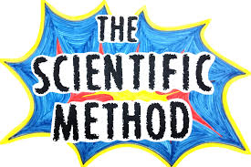
Name Period

_________/14 points

- - POGIL

Objectives: Students will be able to ……
- Define the scientific method.
- Apply the scientific method to solve problems

Information:
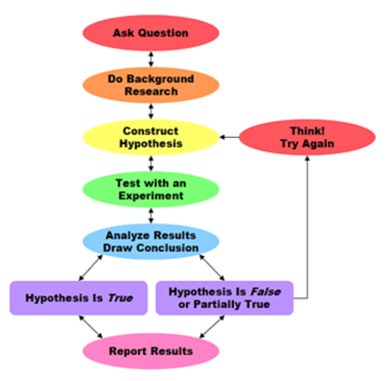
The scientific method is a process of solving problems.

While you may have seen lists of steps to the scientific method, it is not really a step-by-step process. The flow chart describes the problem solving process
After group discussion answer the following questions in complete sentences using the R.A.C.E format.

Why do you think the arrows point both ways between the bubbles of the flow chart? (2 pts)

What happens to a hypothesis that is not supported by the results of an experiment? (2 pts)

If someone reports a hypothesis that you don’t believe what should you do? (2 pts)

One of the benefits of the scientific method is that hypothesis are accepted (considered true) because of experimental data and not because of the reputation of the person making the hypothesis. Explain why this would be considered a benefit. (2 pts)

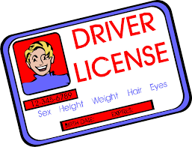
Motor vehicle crashes are the number one cause of death of teens and young adults, accounting for 40 percent of all deaths to teens, ages 16 to 19 in 2002 over 5,000 deaths. Strategies that have been used in an effort to reduce teen motor vehicle crashes and fatalities include raising the driving age, instituting graduated licensing, restricting cell phone use while driving, mandatory seat belt laws, and programs to reduce teen drinking and driving.

New Jersey had originally increased their driving age to 17 but found there was not significant decrease in the number of teen fatalities. They then switched to a graduated license. A New Jersey resident who is 16 years of age (but less than 17) may enroll in a driver education course with a high school or driving school in order to obtain a learner’s permit. When a student is at least 17, has successfully completed the student learner’s permit stage, and has a minimum of six months of supervised driving experience, they may obtain a provisional license. After you’ve held a provisional license for one year and you’ve turned 18, you may receive a basic drivers license after passing the road test.

Explain how New Jersey used the scientific method to form their driver’s license laws. (2 pts)

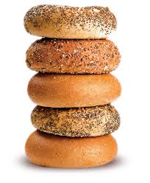
Kelsey is a bagel shop owner and wants to increase her sales. So she asks herself “What could I do to increase the sales of my bagels?” Hint: the front will help!!

Explain how Kelsey could use the scientific method to solve her problem. (2 pts)

