Name Period

Sign up for important updates from Mr. Gedeon.

Get information for John F. Kennedy Middle School right on your phone—not on handouts. Remind.com allows me to safely communicate and connect with students and parents/guardians. It is a safe tool where I can send a text to my students and parents/guardians to remind them of upcoming due dates, tests, etc. Both students and parents/guardians will not be able to reply back to me, nor will they know my personal phone number.

Pick a way to receive messages for 7th Grade Science
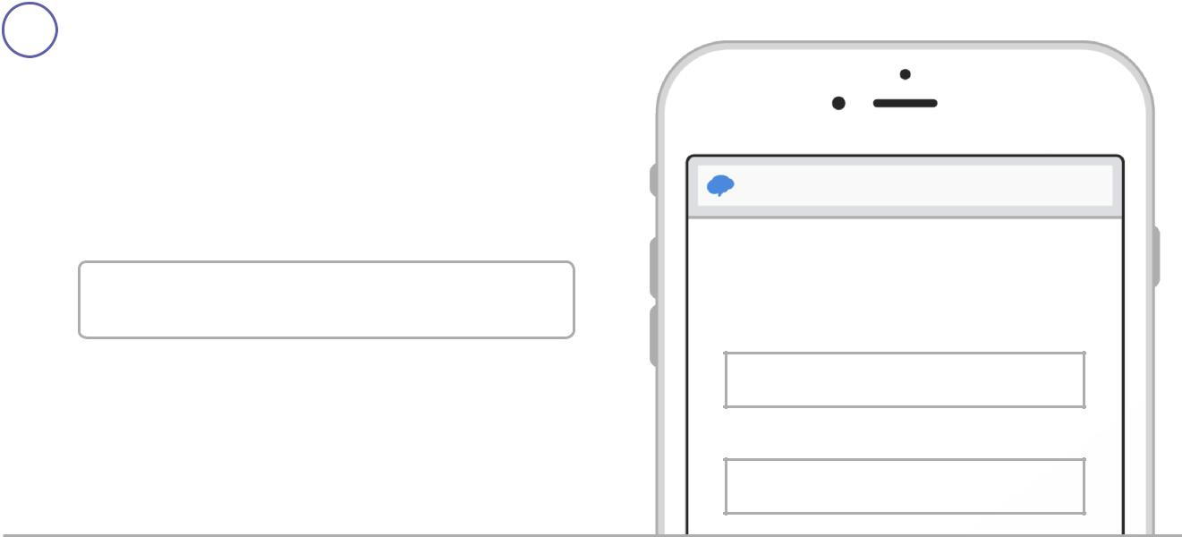

- If you have a smartphone, get push notifications.

On your iPhone or Android phone, open your web browser and go to the following link:

rmd.at/gaae4gh

Follow the instructions to sign up for Remind. You’ll be prompted to download the mobile app.

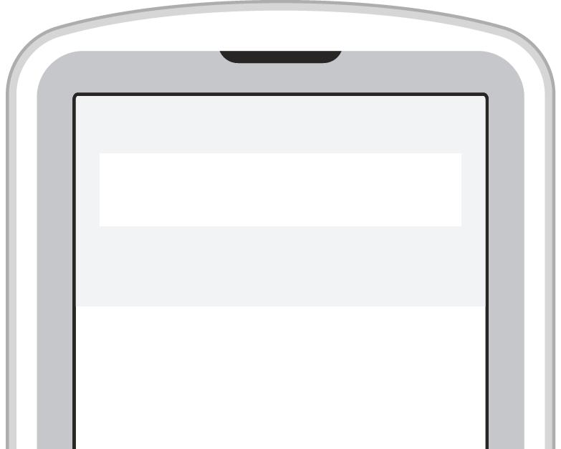
- If you don’t have a smartphone, get text notifications.

Text the message @gaae4gh to the number 81010.

If you’re having trouble with 81010, try texting @gaae4gh to (716) 507-4370.

* Standard text message rates apply.

rmd.at/gaae4gh

Join 7th Grade Science

Full Name

First and Last Name

Phone Number or Email Address

(555) 555-5555

To

81010

Message

@gaae4gh

Don’t have a mobile phone? Go to rmd.at/gaae4gh on a desktop computer to sign up for email notifications.

Dear Parent / Guardian

Please complete this page to help me better understand your child.

- My child has special gifts and talents I would like to brag about. They are:

- If there is one area where my child could use some extra help or coaching, it would be:

- Because of my child’s interests, I think school would be more enjoyable if:

- Something I think you as a teacher might benefit from knowing about my child is:

