Mini Lesson 2: Continental Drift

Continental Drift is the theory that Earth’s crust is resting on a fluid which allows it to move. The crust is broken up into pieces called plates that move relative to each other. These plates are sitting on the asthenosphere (plastic mantle). The transfer of Earth’s internal heat drives convection currents within the mantle that causes these plates to move. When hot rising currents reach the bottom of the plates, it causes them to move apart. When convection currents are sinking it causes plates to move towards each other.

Pangaea is the name that was given to the supercontinent that existed approximately 200 million years ago. There are four main pieces of evidence that support the idea that the continents of today were once part of this single super continent.

- Shape of the coastlines
  - continents fit together like a jigsaw puzzle

- Fossil correlation across ocean basins
  - some fossils found on the east coast of South America are found only on the west coast of Africa

- Rock correlations across ocean basins
  - the rocks on the east coast of South and North America match the same rocks found on the west coast of Africa and Europe.

- Climate changes
  - coal has been found in Antarctica
  - evidence of glaciation in Australia and Africa
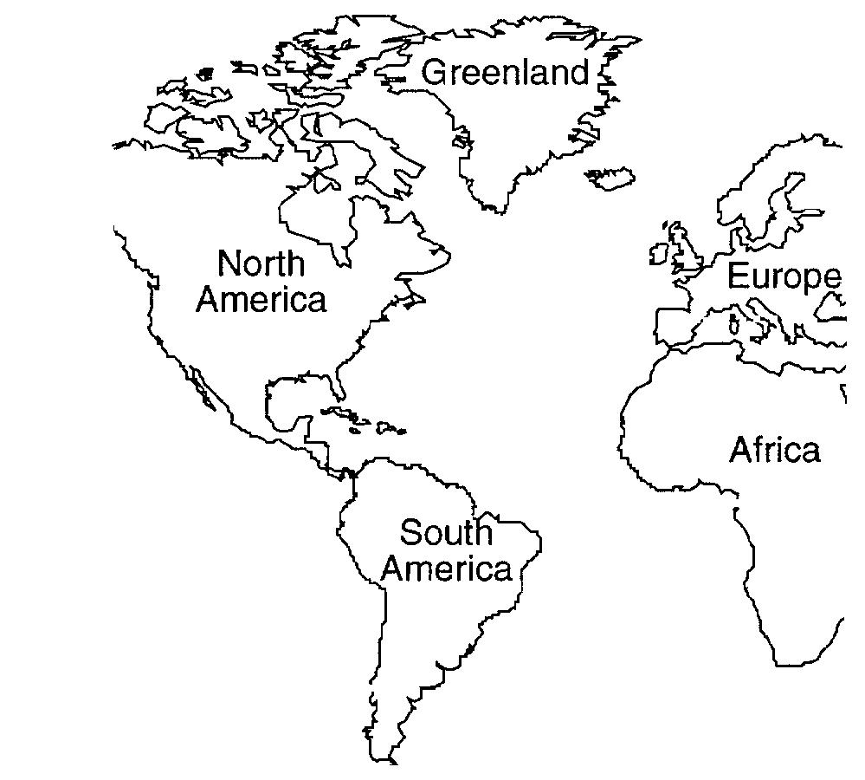

Reading Review:

- What is the theory of Continental Drift? That the Earth’s crust is resting on a fluid which allows the continents to move.
- What layer of Earth are the plates resting on? The plates are sitting on the asthenosphere (plastic mantle).

- What causes the plates to move? The transfer of Earth’s internal heat drives convection currents within the mantle that cause the plates to move.

- What direction do plates move when there is a hot rising current? The plates move apart.

- What direction do plates move when currents are falling? The plate move together.

- What is the name of the supercontinent that once existed? Pangea

- List the four pieces of evidence that the continents were once connected.

a) Shape of the coastlines seem to fit together like a puzzle
b) Fossil correlation - some fossils are found on opposite coasts

c) Rock correlation – rock layers match up on different continents

d) Climate changes – coal, fossils and evidence a glaciation on continents where they currently do not occur.

Show what you know: |  | Continental Drift
1. Using a red color pencil shade in the area labeled |  | Materials
 | ✓ | ESRT’s
Asthenosphere on the diagram below. | ✓ | Highlighter
 | ✓ | Color pencils
- Find the arrow in the asthenosphere near the center of the
diagram that is pointing up. Trace over this arrow with a purple color pencil.

- In the space under the arrow, write “rising currents”.

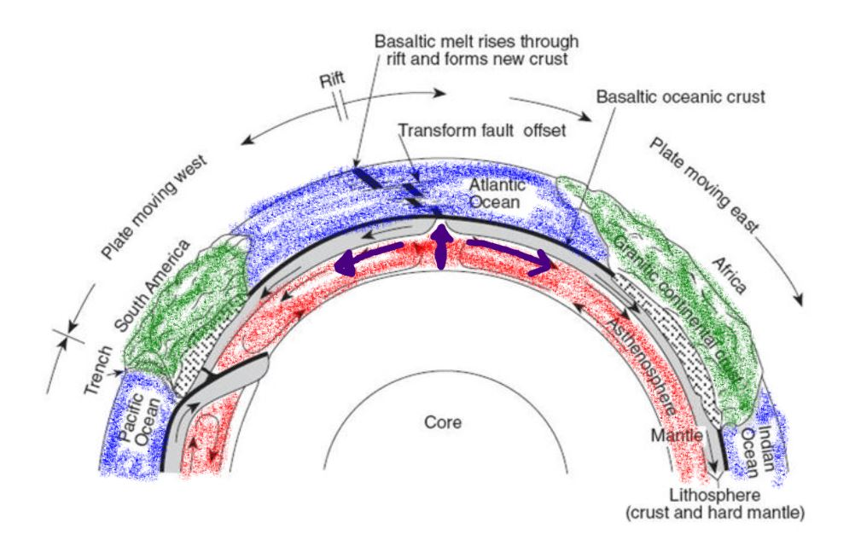

Rising currents

4. Trace the arrow on either side of the, near the top of the asthenosphere purple as well.

These arrows pointing {toward or away from} the rising current.

- What is located on Earth’s surface, directly above the rising current? Mid-Ocean Ridge

- Color the Atlantic Ocean, Indian Ocean, and Pacific Ocean blue.

- The rigid (hard) mantle is the shaded portion of the diagram, directly above the asthenosphere. Look at the arrow under the Pacific Ocean, and the arrow under South America and western portion of the Atlantic Ocean.

These arrows are pointing {toward or away from} the sinking current.

8. Color South America and Africa green.

- Check Point (refer to the diagram on page 8)

1. What feature forms when plates are moving toward each other? trenches

2. What two layers are included in the lithosphere? Crust and mantle

- What is the composition of the oceanic crust? Basalt

- What is the composition of the continental crust? Granite

- What does the basaltic melt rising through the rift form? Mid-Ocean Ridge

- What does the word rift mean? Move apart

- In which compass direction is South American moving? west

- In which compass direction is Africa moving? east

- Using the diagram below and the ESRTs page 10, fill in the chart.
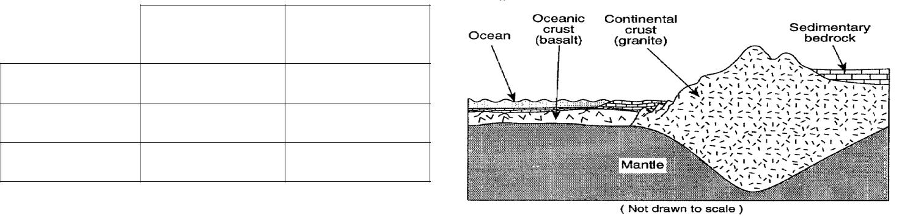

Continental | Oceanic
Crust | Crust

Composition granite basalt

Density 2.7 g/cm³ 3.0 g/cm³

Thickness relatively thin relatively thick

10. Rising current cause the plates to move away from each other.

11. Sinking currents cause the plate to move towards each other.

12. Convection currents are caused by differences in density. Rising currents are {more / less} dense than sinking currents because they are {warmer / cooler}

- Open your reference table to page 5, Tectonic Plates. Highlight the name of the three boundaries listed at the bottom of the page.
Place the names of these boundaries and the information in (parenthesis) in the chart below.

 | Name of Boundary | (description)
 | convergent | move towards each other
 | divergent | move away from each other
 | transform | slide past each other

