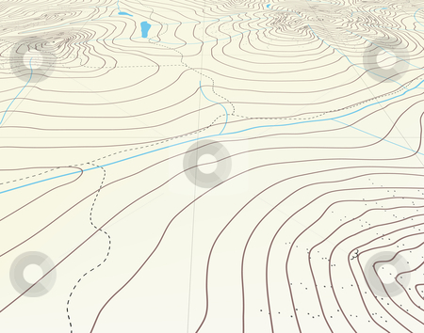
Guided Notes
Topographic Maps
Map scale
Straight line distance
Curved line distance
Rules of Isolines
Contour Lines
Hachured Lines
Possible elevations
Slope & Gradient
Direction of River Flow
Topographic Profiles
- What is a field map?

Map: _________________________________________________________________________

- All good maps have a _______________________________________________________.

Field: ________________________________________________________________________

- How do you determine distance between points using a map?
To determine distance between two locations on the map use the ________________________.
- Map scale: _________________________________________________________________ ___________________________________________________________________________

- If the map scale is in kilometers, the contour lines are elevations in ______________.

- If the map scale is in miles, the contour lines are elevations in ___________________.

There are two ways of determining distance:

- Straight line distance: ________________________________________________________ ___________________________________________________________________________

- Curved line distance: ________________________________________________________ ___________________________________________________________________________

Straight Line Distance:
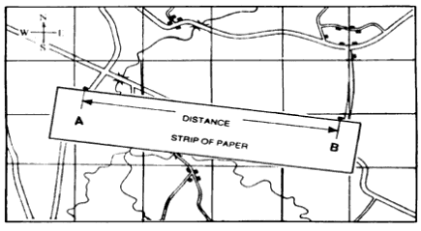
To determine the distance between locations on a map, you will need a piece of scrap paper.

- Place the scrap paper on the straight line between the two locations. You may have to use your imagination sometimes if the line is not drawn for you!
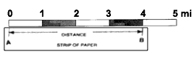
- Make a mark on the edge of the scrap paper at the two locations.

- Move the scrap paper to the map scale so that one of the marks is lined up with zero.

- The other mark indicates the distance.
Example: Determine the straight line distance between the given points using the map below.

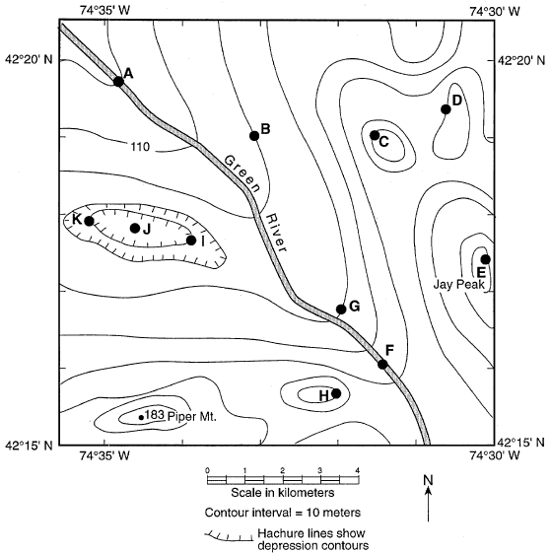 | Points:  1) A and B  2) B and C  3) C and D  4) D and E | Distance:  ____________  ____________  ____________  ____________

Curved Line Distance:

To determine the distance between locations on a map, you will need a piece of scrap paper.
- Place the scrap paper on the straight line nearest your starting point. Mark the location of your starting point on the edge of the scrap paper.
- Make a mark on the edge of the scrap paper where the first straight line distance ends. Make a mark on the map at this exact location.
- Pivot your paper so that it lines up with the next straight line of the feature. Make a mark where this straight-line distance ends.
- Continue this until you have reached your ending point.
- Move the scrap paper to the map scale so that the starting point mark is lined up with zero
- The ending point mark indicates the distance of the entire curved line.

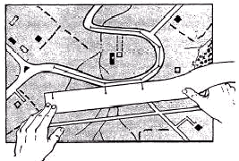

Example: Determine the length of the Green River from Point A to Point F on the map above.

- Checkpoint – Measuring Distances:

- Using ESRT page 3 and a piece of scrap paper, determine the straight-line distance between the following two cities in both miles and kilometers. Note: each city is located at the point near the name of the city.

Cities | Kilometers | Miles
Elmira & Binghamton
Syracuse & Oswego
Ithaca & Utica

- A hiker is using the map below to plan his hike. What is the approximate distance along the trail between point C and D? Label your answer with the correct units.

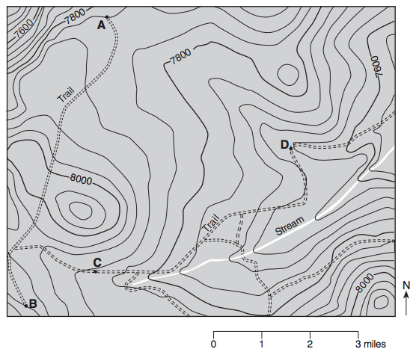
Answer: _______________

- Using ESRT page 3 and a piece of scrap paper, determine the entire length of the Genesee River that is shown on the map, in both miles and kilometers.

Miles: ____________________

Kilometers: ________________

- How do we map fields?

- Isolines: ___________________________________________________________________ ___________________________________________________________________________

In Earth Science, we will spend a lot of time looking at three specific types of field maps:

- Elevation: ________________________________________________________________

- Temperature: _____________________________________________________________

- Pressure: ________________________________________________________________

- Other field maps we will see show snowfall, rainfall, volcanic ash, earthquake magnitudes, odor fluctuations, pollution concentrations

- How do we draw and read isolines?
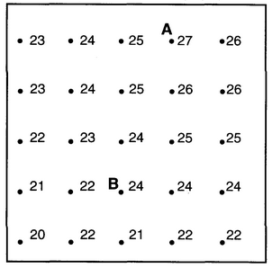
- __________________________________________ __________________________________________ __________________________________________

- __________________________________________ __________________________________________ __________________________________________
__________________________________________ __________________________________________ __________________________________________

- ______________________________________________________________________________________________________________________________________________________

- ______________________________________________________________________________________________________________________________________________________

- ______________________________________________________________________________________________________________________________________________________.
- Checkpoint – Reading Isolines

Students in a class were told to draw the 22 and 24 value isoline on the maps provided. Some of the students made errors. Each map below is incorrect for one reason. Using the rules of isolines, explain why the map is incorrect.

Incorrect Map #1:
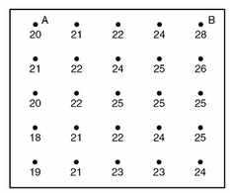

______________________________________________________________________________________________________________________________________________________

Incorrect Map #2:

______________________________________________________________________________________________________________________________________________________

Incorrect Map #3:
______________________________________________________________________________________________________________________________________________________

Incorrect Map #4:
______________________________________________________________________________________________________________________________________________________
______________________________________________________________________________________________________________________________________________________

- Checkpoint – Drawing Isolines

Map #1 Using a pencil, draw isolines with an interval of 1. Work neatly and carefully.

13 | 15 | 16 | 16 | 18
12 | 13 | 14 | 15 | 17
11 | 12 | 13 | 14 | 15
10 | 12 | 13 | 15 | 16

Map #2 Using a pencil, draw isolines with an interval of 2, beginning with 29. Work neatly and
carefully.

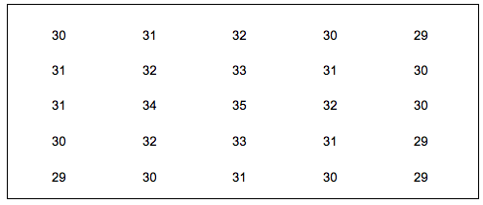

- How is elevation shown on a map?

- Topographic (contour) map: _____________________________________________________ ______________________________________________________________________________

  - Contour line: _____________________________________________________________ ________________________________________________________________________ ________________________________________________________________________

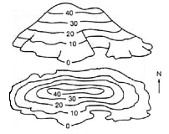
Figure 1.
____________________________________________________________________________
________________________________________________________________________________
    - All elevations are measured above sea level, which has a value of _____________.

      - ____________________________________________________________ ____________________________________________________________ ____________________________________________________________

    - ___________________________________________________________________ ______________________________________________________________________________________________________________________________________

  - Index lines: ______________________________________________________________ ________________________________________________________________________

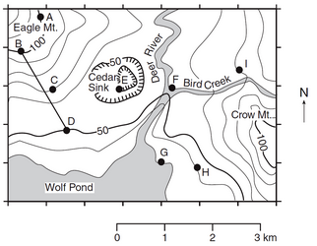
__________________

__________________

- How do you determine values of contour lines on a topographic map?

- Contour interval: _______________________________________________________________ ______________________________________________________________________________

  - ________________________________________________________________________ ________________________________________________________________________.

- Procedure for determining contour interval of a map:

- ________________________________________________________________________ ________________________________________________________________________
- ________________________________________________________________________ ________________________________________________________________________ ________________________________________________________________________.

- Example: What is the contour interval on the map below? _____________________________
80
Lake
40

Elevations in meters

- Checkpoint – Contour Interval: Use the topographic map below to answer questions 1 and 2.
- What is the contour map for the map above? _______________________

- Determine the elevation of the following points using the map above.

C: ________ G: ________ H: __________ I: __________
- The contour map to the right shows a small part of the coast of Maine.
P
Q
Atlantic Ocean

0 1 2

Scale in Miles
Contour Interval = 20 feet
A
B
C
D
N
100
Roth River

  - Which island is less than 20 feet high? How do you know?

  - Which island has two hilltops? How do you know?

  - How far, in miles, is it from point P to Point Q?

- How can you determine possible elevations between contour lines?

- Possible elevations: ____________________________________________________________ ______________________________________________________________________________

  - ________________________________________________________________________________________________________________________________________________

  - Example: What are the possible elevations, in feet, of point X on the topographic map below? ______________________________________________________________

Lake
20
40
X

- How are depressions (or ditches) shows on contour maps?

- Hachured lines ( | | | | | | ): ________________________________________________________ ______________________________________________________________________________

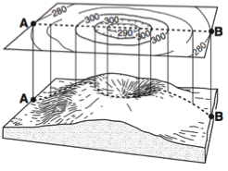
- Rules for reading hachured lines:
290
290

- _____________________________________________ _____________________________________________ _____________________________________________

- _____________________________________________ _____________________________________________ _____________________________________________

- Example: On the map below, what is the elevation of point E? __________
________________________________

- Checkpoint – Possible Elevations & Hachured Lines:

  - Use the topographic map below to answer the following questions. Elevations are in feet.

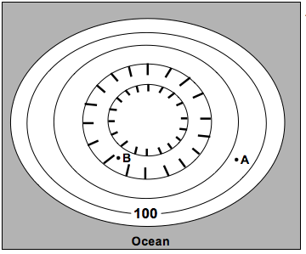

  - Find the contour interval of this map. _______________________________________

  - Label the elevation of all of the contour lines.

  - State the highest and lowest possible elevation of:

Point A: Highest = _______________ Lowest = _______________
Point B: Highest = _______________ Lowest = _______________

  - The following questions refer to the topographic map below which shows elevation in meters.

- What is the contour interval of the map? ___________________________
- What is the lowest possible depth of the depression? ________________
- What is a possible elevation of point P? ___________________________
- How are changes in slope shown on a topographic map?

- Slope: ________________________________________________________________________ ______________________________________________________________________________

- __________________________________________________________________________ __________________________________________________________________________

- __________________________________________________________________________ __________________________________________________________________________
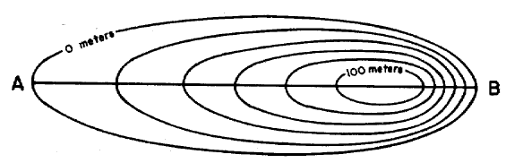
________________________
________________________

- Checkpoint – Slope:

  - Which mountain on the map below has a steeper slope? How do you know?

- How can the steepness of a slope be calculated?

- Gradient: _____________________________________________________________________ _____________________________________________________________________________

- Field values: _____________________________________________________________ ________________________________________________________________________

    - On a topographic map, the field values are ________________________________.

- Equation for gradient (found on ESRT front cover)
________________________

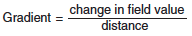
________________________

- Example Problem: Point A and point B are locations 0.24 mile apart on a ski slope in northern New York. Point A has an elevation of 1,560 feet and point B has an elevation of 1,800 feet. What is the gradient between these points? Show your work.

- Checkpoint – Gradient:

  - Determine the gradient between point B and D on the map below. Show your work.
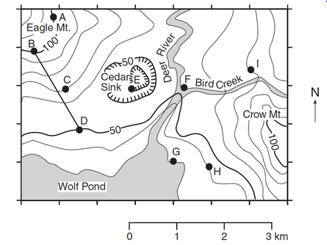
  - The topographic map below shows a stream crossing several contour lines and passing through points X and Y. Elevations are measured in feet.
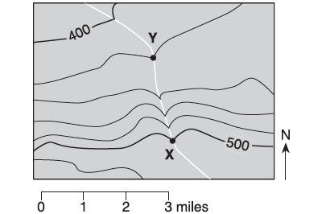

What is the approximate gradient between point X and point Y? _____________________

  - The topographic map below shows a hill. Points X and Y represent locations on the hill’s surface. Elevations are shown in meters.
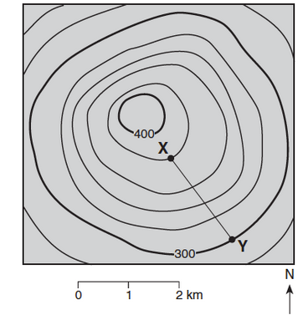

What is the gradient between points X and Y? ___________________________________

- How can the direction of river flow be determined using a topographic map?

River Flow Direction:

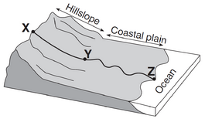
- _______________________________________________ _______________________________________________ _______________________________________________

- ________________________________________________________________________ ________________________________________________________________________.
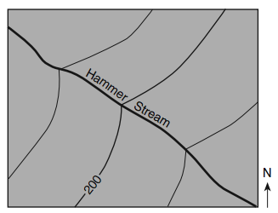

- ________________________________________________ ________________________________________________ ________________________________________________

- Example: Which direction is the Hammer Stream flowing?
_________________________________________________

- Checkpoint – River Flow:

Base your answers to questions 1 and 2 on the topographic map below.
- Which direction is the Deer River flowing? _________________________________________

- Which direction is the Bird Creek flowing? _________________________________________

- The topographic map below shows a lake and two rivers.

In which direction does each of the rivers flow?

Sapphire River: __________________________________

Garnet River: ____________________________________

- On the map below, circle the stream that is flowing away from Hayes Lake.

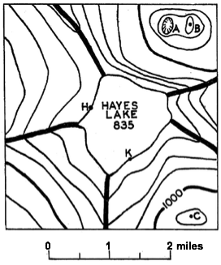

- What do features on a topographic map look like in real life?

- Profile: _______________________________________________________________________

- Profile Construction
  - Mark the elevation of each contour or hachured line on the map above the location where you will place your scrap paper.
  - Place a strip of paper along the profile line on the contour map.
  - Make a mark on the strip of paper wherever the paper crosses a contour line and label the marks with their value.
  - Place the strip of paper along the edge of the grid.
  - Project the marks upward to locate the points on the profile.
  - Draw a smooth line connecting the points. Note: hilltops and depression bottoms are not flat; the profile has to be rounded off.

- Example: Construct a profile for the topographic map below.

120
100
80
60
40
20
0
A
B

- Checkpoint – Profile Construction

- The topographic map below shows a small island in an ocean. Points A, B, C, and D represent surface locations on the island. A triangulation point is shown at the highest elevation on the island. Elevations are measured in feet and distances are measured in miles.
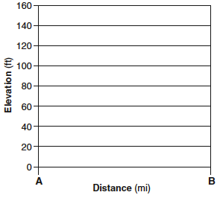
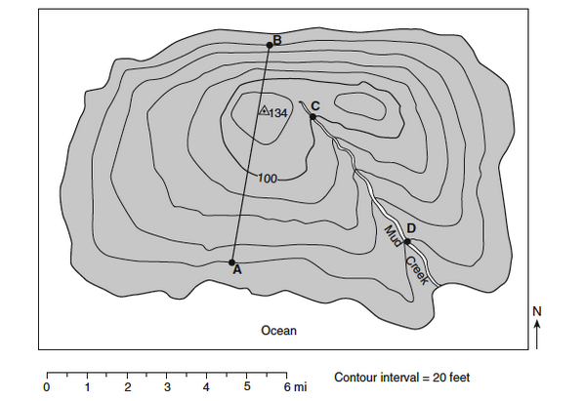
On the grid to the right, construct a profile along line AB by plotting a point for the elevation of each contour line that crosses line AB. Connect the points with a smooth, curved line to complete the profile.

- The diagram below is a topographic map of a depression and a hill on a gently sloping area. Points A, X, and Y are locations on Earth’s surface. A dashed line connects points X and Y. Elevation is indicated in feet.

On the grid below, construct a topographic profile along line XY, by plotting a point for the elevation of each contour line that crosses line XY. Points X and Y have already been plotted on the grid. Connect the points with a smooth, curved line to complete the profile.
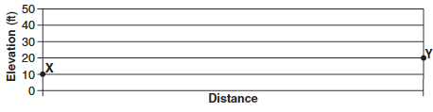

- The topographic map of an island is shown below. Elevations are expressed in feet. Points A, B, C, and D are locations on the island. A triangulation point is shown at the highest elevation on the island.
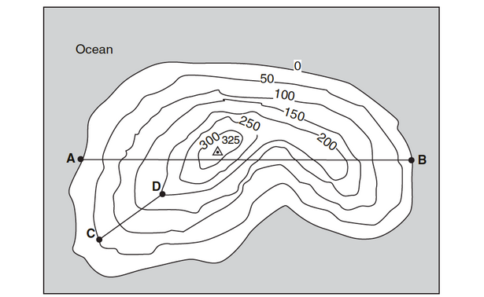
On the grid below, construct a topographic profile representing the cross-sectional view between point A and point B, following the directions below.
- Plot the elevation of the land along line AB by marking with a point the elevation of each point where a contour line is crossed by line AB.
- Connect the dots with a smooth, curved line to complete the topographic profile.

Profile Multiple Choice
- Check the elevation of the starting and ending points. Eliminate any wrong choices.
- Move your pencil along the straight line between the two letters to see how the elevation of the land changes.

- Checkpoint – Profile Multiple Choice

- Which cross-section best represents the profile along straight line AB?

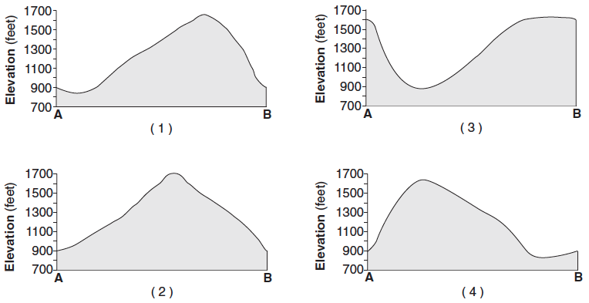
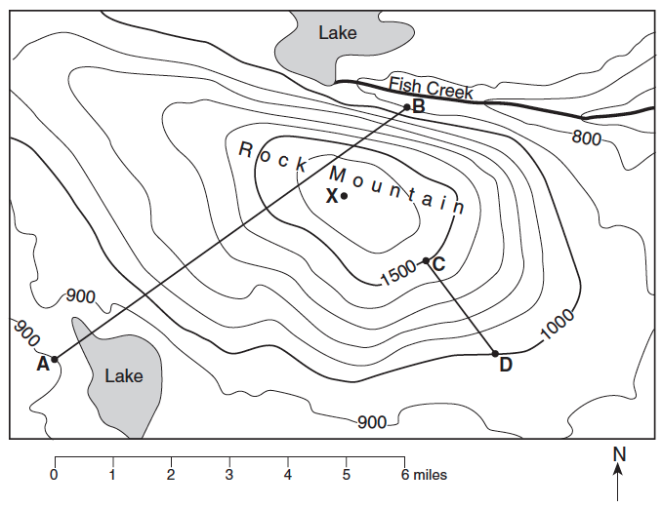

- The contour map below shows elevations in meters. Line AB is a reference line on the map. Which graph best represents the profile along line AB?
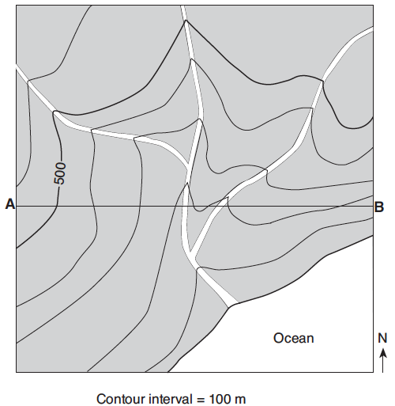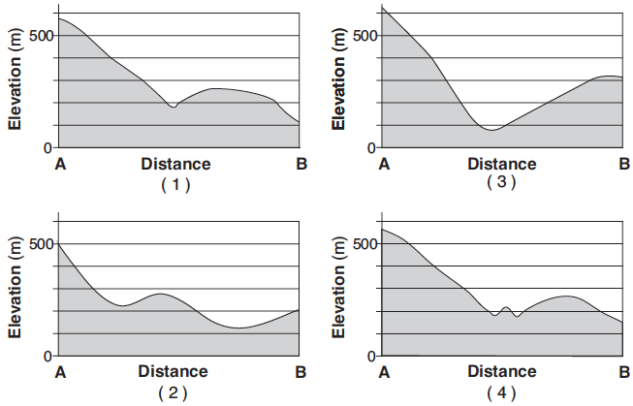
- Checkpoint – Contour Maps

Base your answers to questions 1 through 5 on the topographic map below. Points A, B, Y, and Z are reference points on the topographic map. The symbol ▲ 533 represents the highest elevation on Aurora Hill.
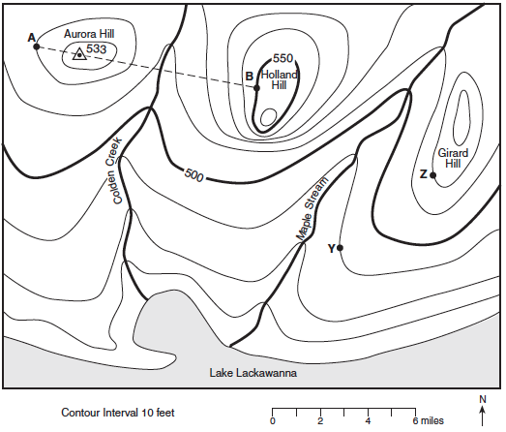

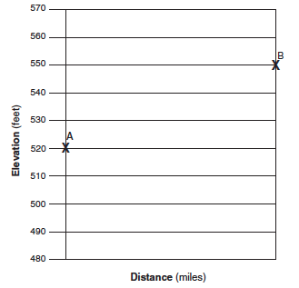
- What is the contour interval of this map? ________

- In which general compass direction is Maple Stream flowing? Explain how you knew.

- Calculate the gradient between points Y and Z. Show your work and label your answer with units.

- What evidence shows that the southern side of Holland Hill has the steepest slope?

- On the grid to the right, construct the topographic profile from point A and B.

Base your answers to questions 6 through 10 on the below diagram which represents a contour map in the making. Each number represents the elevation of that place above sea level.

691
688
701
685
703
707
712
713
726
715
707
703
689
682
Frier Pond
THOMAS
A
N
BROOK
695
691
B

- Starting with the 690-foot contour line and using a contour interval of 10 feet, draw four complete contour lines.

- Shade the area that would be under water if the level of Frier Pond rose 8 feet.

- Which slope is steeper, A or B? ____________________________________________________

- In which direction does Thomas Brook flow? __________________________________________

- State one way in which a contour map would be useful to the following people:

  - A farmer: ________________________________________________________________ ________________________________________________________________________
  - A hiker: _________________________________________________________________ ________________________________________________________________________

Base your answers to questions 11 through 14 on the topographic map below. Elevations are in feet. Points A and B are locations on the map.
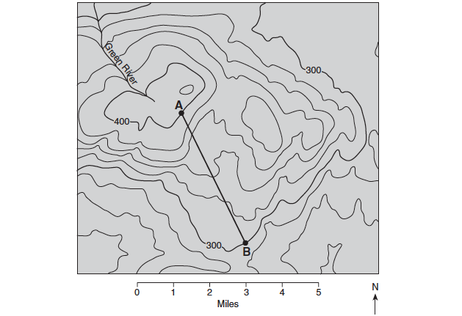

- Toward which direction does the Green River flow?
  - northeast b. northwest c. southeast d. southwest

- What is the gradient along the straight line between points A and B?
  - 10 ft/mi b. 20 ft/mi c. 25 ft/mi d. 35 ft/ mi

- Which graph best represents the profile along line AB?
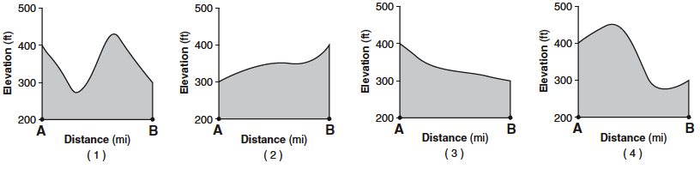

- What evidence can be used to determine that the land surface in the northeast corner of the map is relatively flat?
  - a rapidly flowing river c. a dark contour line labeled 300
  - a large region covered by water d. the absence of many contour lines

